Quadruped Robot For Smart Agriculture

Team: Austin Neff, Kevin Nelson, Jordan Raver, Ben Siesser, Sam Spencer, Yang Yang

Team Advisors: Shad Roundy, Kam Leang

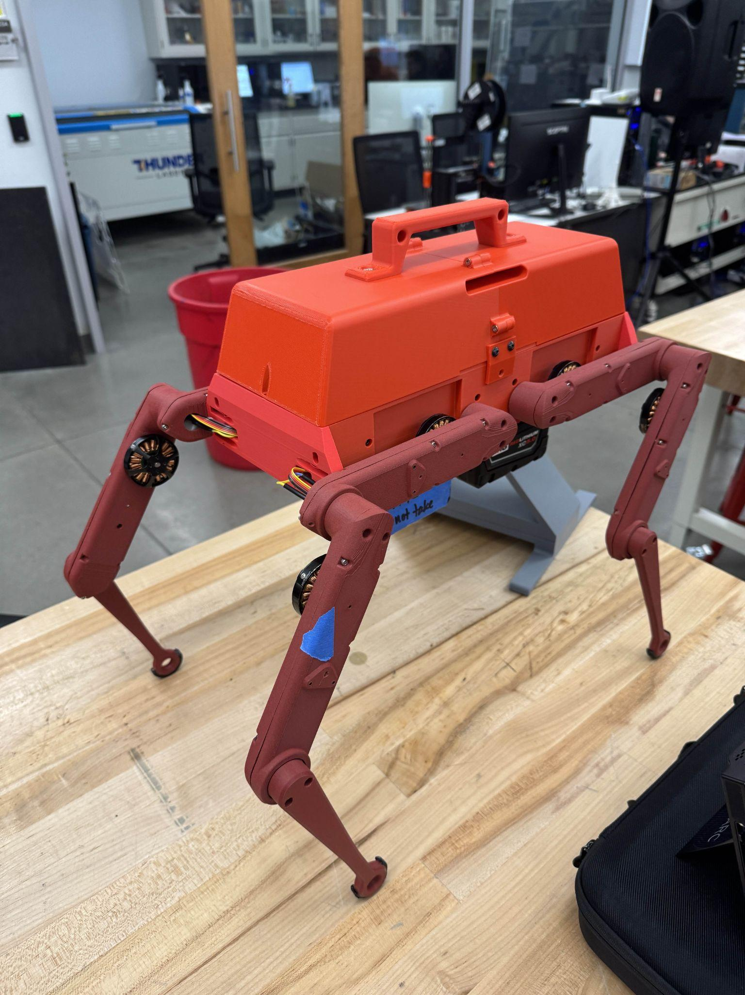

**Executive Summary**

The Quadruped Robot for Smart Agriculture project aims to develop a cost-effective and adaptable robotic platform for agricultural applications. Designed to operate autonomously in diverse environments, the robot is intended to do tasks such as field inspection and soil sampling.

The primary objectives of this project are to build a quadruped robot with software that runs on ROS 2 Humble, features wireless control, contains an onboard power system, has all the electronics enclosed, costs under $6,000, and has the documentation needed to replicate the robot. The design must also meet specifications such as structural integrity, reliable motor torque, and accurate inertial measurement. Eventually, a field-ready robot could include manipulators, advanced navigation, and additional sensors. However, these aspects are out of the current scope for this semester.

The robot's key components include a main chassis housing electrical systems, actuated legs, and an Orange Pi-based control system. The power supply consists of two Milwaukee M18 batteries with mounting points for said batteries on the underside of the robot. Our team employed finite element analysis (FEA) to validate leg strength, achieving a safety factor of 5.7. Preliminary motor torque tests confirmed the robot can support its weight, but additional evaluation is required to meet ISO standards for agricultural machines.

To date, several milestones have been completed, including chassis assembly and partial leg actuation. However, challenges persist in full motion execution due to motor driver communication issues, which have delayed power system verification and walking trials. Wireless connectivity has been tested successfully in controlled environments. The project so far has spent $4,423.31, well below the $6,000 budget.

The team’s focus for the rest of the semester will include refining motion algorithms, optimizing stability through IMU integration, and performing validation tests. The team also aims to document all hardware and software components comprehensively. This project has the potential to provide a scalable platform for smart agriculture and research applications.

**Acknowledgments**

All the Team Members are very grateful to Professors Roundy and Leang for their mentorship in this project. Their expertise was invaluable in creating this robot.

1. **Design Requirements**

Our advisors gave us the design requirements at the beginning of the semester during an in-person meeting with them. These requirements can be seen in Table 1. Requirements were chosen based on the need to integrate with their current laboratory and research projects. In addition to this, as a result of our interviews with potential end users, we determined additional requirements that the base robot platform would need to be a feasible alternative to quadcopter drones in agriculture. In the future, this robot could be used to inspect canals, drainage ditches, soil samples, or perform basic weeding. However, making any attachments or manipulators for such future work is outside of the scope of this group’s work.

Table 1: Design Requirements

| Must be part of scope | Optional Scope | Not included in Scope |
| --- | --- | --- |
| 1. Runs on ROS 2 Humble 2. No tether; wireless control 3. On-board Power System that can run for minimum 30 minutes 4. Modify design to enclose electronics   –weathertight   1. Easily storable, carryable (handles, box) 2. Utah red colors 3. Total robot price < $6000 4. Include sufficient documentation to replicate robot | 1. Can navigate to four points in a field. 2. Rebuild chassis with stronger materials during second semester (fiberglass infused ABS) | * Additional actuators * Additional sensors * Efficient walking * Manipulators * Radio beacon triangulation * 12 degrees of freedom |

1. **Design Specifications**

Design specifications were chosen due to them being what is needed for the robot to balance and perform its expected tasks. Our team advisors helped us greatly in coming up with the goal values. No metrics were determined via simulation, all achieved values are the result of real world physical testing from the prototype.

The ability for the robot to stand and walk under its own weight was the most important specification we had to meet. If the robot does not have the power to stand up then there is no way for us to meet any other design specifications. Further, we want it to be able to support an additional load equal to 50% in order to meet ISO standards for self-propelled agricultural machines. In order to verify that we could meet this, we constructed a test stand for one leg actuator, commanded it to 90 degrees for the worst case load scenario, then added weight to it until it could not support itself and moved. The results were that, at the worst case angle, the robot could support 495 grams at 5 amps. This corresponds to a torque of 0.714 Nm, which we can extrapolate to 2.142 Nm per motor. We can do this because torque and current are directly proportional, so in the final, battery powered configuration of our robot when we can draw 15 A per motor, the torque would be 3 times what we tested. This then converts to 3.16 lbs per motor, or 12.64 pounds of lifting force total. The weight of our robot is 10.356 pounds. This suggests we at least have the ability to stand up, though with the current battery arrangement it seems we will be unable to meet the ISO standards, though further testing is required. Once we have resolved a few final control issues, we will be able to directly test the robot’s ability to stand under a load.

The robustness and strength of the robot chassis and support were an essential specification we had to meet. We need to be sure that the materials can also support the robot, not just the motors. We ran an FEA analysis last semester on the lower leg segment components and determined we had a factor of safety on physical strength of 5.7. The details of this analysis are found in Appendix B.

The team knew that staying stable on rough terrain that may be encountered in a field would be difficult if the IMU had a low resolution. The greater the resolution, the easier it is to maintain stability. It was decided to match the specifications in the Open Dynamic Robot Initiative on this count. We have yet to complete testing to verify its capabilities

The robot is expected to eventually be able to operate in large fields. Our advisors directed us to target a minimum runtime of 30 minutes to accommodate this. Once all four legs are actuated we can do a runtime test.

One reason why our team advisors gave funding for this project was to have an affordable quadruped robot to do research on. Off the shelf quadruped robots generally cost in the range of $50k-$100k and a much cheaper alternative for their laboratory would be extremely beneficial. Further, these expensive robots are typically locked down and cannot be modified on the software or hardware level. Having a cheaper, more open alternative is our ultimate goal. Our team advisors gave us a budget of $6000 to make a single robot. In addition, when discussing cost with possible end users, it was determined that $10000 would be the upper limit where a quadruped in agriculture stops making sense as an alternative to quadcopters.

Eventually in the field, this robot will need to receive updates and upload information to the end users. For this to be effective, the robot needs to have a wireless delivery range of 1000 ft. With the current setup, wireless range is determined by how far the wifi network it is connected to extends. In other words, so long as the usage area is covered by the same wifi network as the one the control device is connected to, range is not an issue.

Table 2: Specifications

| Customer Needs # | Metric | Units | Goal Value | Achieved value | Midterm Status |
| --- | --- | --- | --- | --- | --- |
| 1 | Ability for robot to stand and walk under its own weight | Lbs | >1.5 * total weight = 15.534 | 12.64 | Preliminary test complete, further testing required |
| 2 | Robustness and strength of the robot chassis and supports | Lbs | >1.5 * total weight = 15.534 | 16.73 | Complete |
| 3 | Accuracy of inertial measurement | mgs | 0.1 |  | Not yet complete |
| 4 | Response Time | ms | 200 |  | Not yet complete |
| 5 | Robot runtime while all motors are moving | min | 30 |  | Not yet complete |
| 6 | Cost of the robot | $ | <6000 | 4500 | Complete |
| 7 | Wireless Delivery | ft | 1000 | Controlled by external factors | Complete |

1. **Engineering Standards**

The standard that is applicable to our project is the ISO standard for agricultural machinery. It is used for self propelled machines of various types, which our project falls under. This standard determines the load bearing capacity our robot needs to support. It states that the mechanical supports on the robot (in this case, the legs) should be able to support 1.5 times the target load. Though our material choices can meet this requirement, our current analysis suggests the motors will be unable to produce enough torque. Other specifications in this standard we considered are electrical system specifications, which require our electrical systems to be protected from fluids and kept away from moving parts and sharp edges. We have designed the body with this in mind, both for this specification and our user needs. Further, it is necessary to include an emergency stop system, which we are planning on including but have yet to implement.

More information on this standard can be found in the following URL:

<https://compass.astm.org/document/?contentCode=ISO%7CISO%204254-1%3A2013%7Cen-US>

1. **Final Design**

The design of the robot includes the following subsystems: chassis, legs, power, and software.

**Chassis**:

The chassis was designed to house all electrical components such as the IMU, Odrives, orange pi, fuses, breaking resistors and wires in a watertight manner, with considerations for airflow. The legs are attached on the sides of the chassis. The mounting brackets were designed to be easy to access while still being compact enough to house all the necessary items.

The two batteries hang down below the chassis, attached to it by the Milwaukee adapter points. The chassis with components can be viewed in Figure 1.

**Legs**:

The legs are composed of three parts: the upper leg, middle leg, and lower leg. The upper leg is fixed to the body on the sides of the chassis by four M3 screws that are connected to the heated inserts in the chassis. The upper leg houses all the components necessary for the actuation of the middle leg, and the wires for the middle leg run through it. The middle leg is connected to the upper leg by two M3 screws, it houses all the components necessary for the actuation of the lower leg. The actuator design is identical to that of the upper leg. The lower leg is connected to the middle leg by two M3 screws, it does not house any components and is a solid part.

All leg components are made of CF-PLA, all leg parts besides the lower leg are 40% infill. 16 wires are routed from the leg to the body, 8 for each motor and encoder pair. There are a series of belts and gears that provide a 10:1 gear ratio to ensure sufficient torque. The actuator design is copied directly from the Open Dynamic Robot Initiative, and can be seen in appendix C, as part of our original scope.

Currently the robot has cut RC car tires as the traction point on the bottom. For the final prototype, we will replace these with 3D printed spherical “shoes” made of TPU, so they can be easily replaced once worn down.

**Power**:

The battery is a pair of M18 batteries commonly used for power tools. They were chosen for easy integration into our advisors’ laboratories, high capacity of 5 amp hours, and easy removal for charging. They are linked to a power distribution board which sends 18 V and up to 15 A to each motor and a 5 V 4 A signal to the Orange Pi, which then distributes 3.3 V or 5 V signals to our sensors as needed.

**Software**:

The software is designed to enable wireless control of the robot. We can send commands to the Orange Pi via SSH, which are then interpreted by a ROS node to determine what motions to execute. Currently, that is in the form of bash scripts that sends messages containing two joint angles to a node for each leg. These leg nodes then reformat the joint angles into a message that the ODrives can understand, and forwards those onto the CAN bus for the drivers to interpret. We also have a node that reads IMU data and passes it to a currently unwritten node. Due to the limited computational load on these nodes and compatibility with the IMU and ODrive, these nodes are written in Python. In the future, we will add a second leg node, written in C++ to maximize response speed, on top of the other that takes in a coordinate position and performs inverse kinematics to generate the joint angles the legs need to achieve to reach the target coordinates. Further, the bash scripts will be replaced with a pair of C++ ROS nodes. The first will read keyboard inputs to determine what mode of movement to execute, and send that information on to the next node. This second node is our central command node, and will control the state switching for each leg, the loading of primitives, and modification of information due to IMU data. IMU data will be filtered then converted from orientation to a vertical offset by a service, to alter how far the legs need to move to maintain a level body, then returned to the central command node. The state switching will control what portion of a motion cycle a given leg is on, and the primitives will provide a basic set of positions that can be modified by IMU data to determine how the legs need to move to perform specific motions such as walking or sitting.

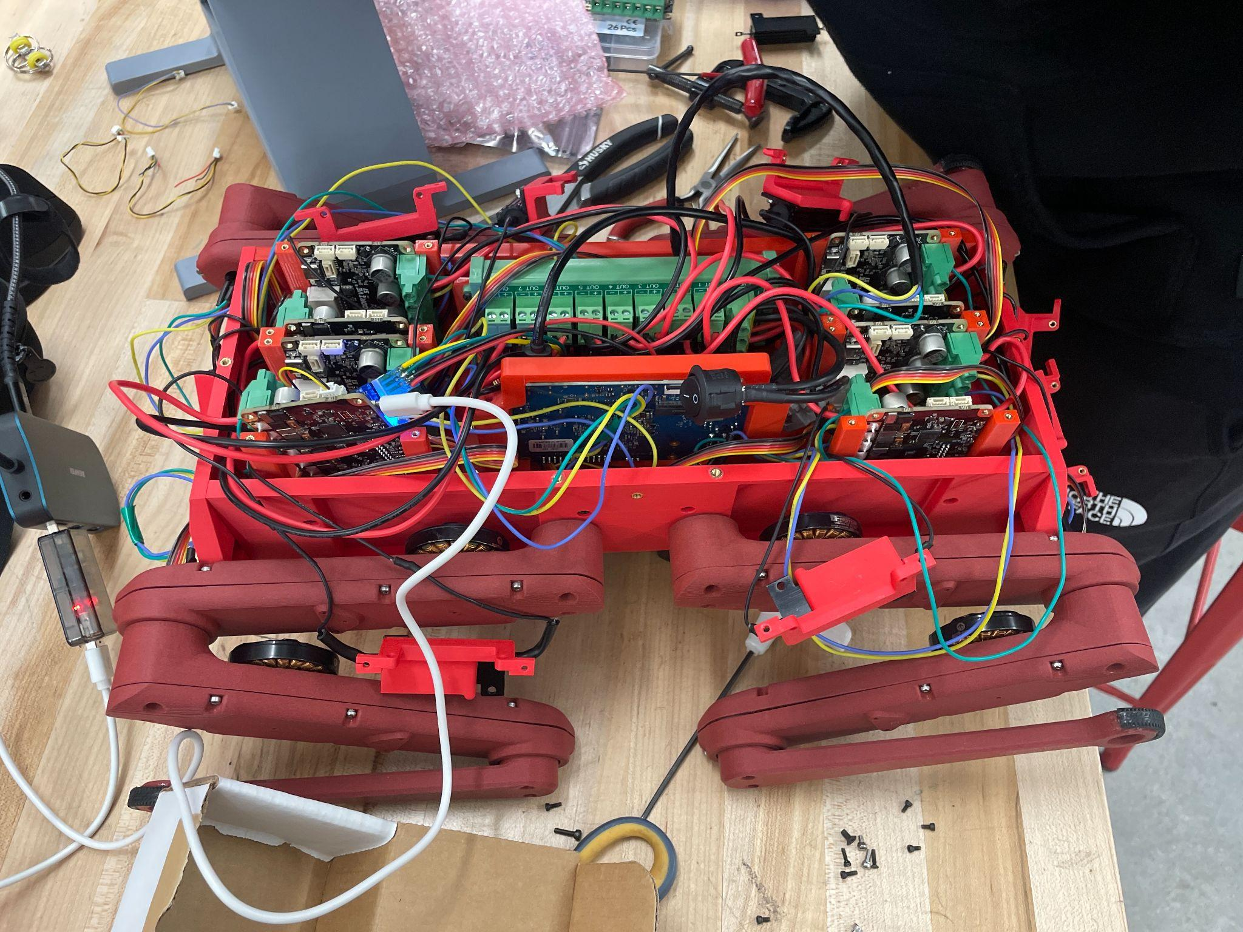

Figure 1: The internals of the robot

1. **Performance Verification**

Of the seven design specifications, two of them have been tested or evaluated. Those are numbers 2 and 6.

1. The ability for the robot to walk under its own weight has not undergone a full test due to the robot currently only having three functional legs. However, the three working legs were told to hold a standing position and the robot was able to support its own weight while a team member balanced it by hand. Because of this we are confident that the robot will be able to support itself, but will do a formal test as soon as we can
2. The robustness and strength of the robot chassis to support itself supports an additional weight equal to 50% of the robot’s weight without any yielding.
3. The accuracy of the inertial measurement unit (IMU) has not been tested yet, but the IMU purchased has specifications within the needs of the robot.
4. The response time test has not been performed yet
5. The robot runtime test has not been performed yet
6. The current cost of the robot is $4,423.31, this is well below the $6,000 available and everything has been ordered except spare parts. Total ordering information can be found in Appendix 1.
7. The wireless delivery range is limited by components outside of the robot, but for testing at the U we would comfortably exceed 1000 feet as the U’s network extends well beyond that range.
8. **Budget**

As of February 6th the total amount of money spent has equaled $4,423.31, this is well below the $6,000 available and everything has been ordered including some spare parts. The breakdown of the budget is provided in Appendix A. The only likely purchases we would make for the rest of the project are for additional sensors to meet our optional scope.

1. **Future Work**

The two remaining mandatory milestones are:

1. On-board Power System can run for minimum 30 minutes
2. Full motion of robot, able to walk distances consistently without issues in varied environments including outdoor areas

We are behind schedule on these milestones, due to issues with serial communication with the motor drivers. However, the majority of the code necessary for these is complete and just needs to undergo testing, beginning next week as we have finally resolved the communication issues.

The two remaining optional milestones are:

1. Basic Navigation to beacons using GPS or towards a radio frequency (optional scope)
2. Optimize Navigation to path-find to four beacons in different locations (optional scope)

This optional scope will be approached as we complete required scope and team members find themselves without work. The plan to achieve the remaining milestones can be seen in Table 3.

Table 3: Gantt Chart

| **TASK TITLE** | **PCT OF TASK COMPLETE** | **Febuary** | | | | **March** | | | | | **April** | | | |
| --- | --- | --- | --- | --- | --- | --- | --- | --- | --- | --- | --- | --- | --- | --- |
| **3** | **10** | **17** | **24** | **3** | **10** | **17** | **24** | **31** | **7** | **14** | **17** | **24** |
| Power system test | 0% |  |  |  |  |  |  |  |  |  |  |  |  |  |
| Walking software | 80% |  |  |  |  |  |  |  |  |  |  |  |  |  |
| Basic motion achieved | 50% |  |  |  |  |  |  |  |  |  |  |  |  |  |
| Build full prototype | 100% |  |  |  |  |  |  |  |  |  |  |  |  |  |
| All legs mounted and wired | 100% |  |  |  |  |  |  |  |  |  |  |  |  |  |
| Body complete with lid | 90% |  |  |  |  |  |  |  |  |  |  |  |  |  |
| Flat Terrain Testing, Debugging | 0% |  |  |  |  |  |  |  |  |  |  |  |  |  |
| Walks with no tether | 0% |  |  |  |  |  |  |  |  |  |  |  |  |  |
| All design requirements fulfilled | 10% |  |  |  |  |  |  |  |  |  |  |  |  |  |
| All deliverables delivered | 0% |  |  |  |  |  |  |  |  |  |  |  |  |  |
| Presentation |  |  |  |  |  |  |  |  |  |  |  |  |  |  |
| presentation board |  |  |  |  |  |  |  |  |  |  |  |  |  |  |
| prep for design day |  |  |  |  |  |  |  |  |  |  |  |  |  |  |
| Design Day |  |  |  |  |  |  |  |  |  |  |  |  |  |  |

1. **Project Deliverables**

It is essential that proper documentation is given to allow future users the ability to modify the platform we have developed or replicate it. Further, we need to provide a working prototype to build on directly.

Final deliverables (Status, date it will be delivered):

* Final assembled robot (In Progress, April 7th)
* Email\flash drive with all code and 3d printed part models (In Progress, April 7th)
* ME EN 4010 Final Report, poster presentation files (In Progress, April 7th)
* Documentation for setup and code use (In Progress, April 7th)
* Bill of Materials (In Progress, April 7th)
* Videos of robot working (In Progress, April 7th)
* Any spare or extra parts and materials (In Progress, April 7th)

1. **Conclusions**

In conclusion, a quadruped robot has been designed to fulfill the requirements necessary to be useful in smart agriculture. A prototype has been built, with all necessary hardware present and working, to demonstrate the feasibility and concept of such an endeavor. However, several more milestones on the code implementation must be completed in the time before design day. These include getting the robot to walk, specification tests, and preparing the robot and associated documentation to be handed off to whoever uses it next.

**Appendix A: Bill of Materials**

| **Part** | **Supplier** | **Quantity** | **Price Individual Part** | **Price All Parts** |
| --- | --- | --- | --- | --- |
| M3 x 5 SS (50 pcs) | [mcmaster](https://www.mcmaster.com/products/screws/flat-head-screws~/flat-head-profile~standard/system-of-measurement~metric/metric-316-stainless-steel-hex-drive-flat-head-screws/) | 1 | $5.09 | $5.09 |
| M3 Screw and Nut Assortment | [Amazon](https://www.amazon.com/dp/B0B51BFSWZ/ref=sspa_dk_detail_2?psc=1&pd_rd_i=B0B51BFSWZ&pd_rd_w=AOTFq&content-id=amzn1.sym.8c2f9165-8e93-42a1-8313-73d3809141a2&pf_rd_p=8c2f9165-8e93-42a1-8313-73d3809141a2&pf_rd_r=FJY2F30S8SZP8D12B2QF&pd_rd_wg=l9asT&pd_rd_r=594f0113-1cfb-4b98-894f-7151754a2d90&s=hi&sp_csd=d2lkZ2V0TmFtZT1zcF9kZXRhaWw&smid=A23XVIPJ96UME3) | 1 | $7.99 | $7.99 |
| M3 x 4.5 Helicoil (10 pcs) | [mcmaster](https://www.mcmaster.com/products/threaded-inserts/threaded-inserts-2~/stainless-steel-helical-inserts-9/) | 3 | $8.98 | $26.94 |
| M3 x 6 Helicoil (10 pcs) | [mcmaster](https://www.mcmaster.com/products/threaded-inserts/threaded-inserts-2~/stainless-steel-helical-inserts-9/) | 3 | $11.35 | $34.05 |
| Brushless Motor (2pk) | [T-Motor](https://store.tmotor.com/product/mn4004-kv300-motor-antigravity-type.html)* | 4 | $145.90* | $583.60* |
| Bearing Output Shaft | [123-Bearing](https://www.123bearing.com/bearing-housing/deep-groove-bearing/single-row/61705-2rs?gad_source=1&gclid=Cj0KCQjwiuC2BhDSARIsALOVfBLTtf_wx8QmTYzEErM5VmS_L0-OCCcSK4K_FfiNdRsoK2PocKlsLKQaAqzOEALw_wcB) | 16 | $5.02 | $92.42 |
| Bearing Motor Shaft and Center Shaft | [123-Bearing](https://www.123bearing.com/bearing-housing/deep-groove-bearing/single-row/mr84-ezo?gad_source=1&gclid=Cj0KCQjwiuC2BhDSARIsALOVfBLP6zc2D7WI78cAX-wvPuipUXAhRfhm4ViEobpSNPHtPp2gaRZUCqoaAl5xEALw_wcB) | 24 | $8.03 | $166.56 |
| Bearing Timing Belt Tensioner | [123-Bearing](https://www.123bearing.com/bearing-housing/deep-groove-bearing/single-row/683-zz-ezo?gad_source=1&gclid=Cj0KCQjwiuC2BhDSARIsALOVfBJvnXByl5luDD8K-qQIBbE7xVEqaPmOi-kKv8cbh-WROOkpH6PaLOsaAo3hEALw_wcB) | 16 | $6.24 | $112.64 |
| Timing belt first stage | [Belting Online](https://www.beltingonline.com/at3-gen-iii-synchroflex-timing-belts-4593) | 8 | $5.96 | $47.71 |
| Timing belt second stage | [Belting Online](https://www.beltingonline.com/at3-gen-iii-synchroflex-timing-belts-4593) | 8 | $8.94 | $71.53 |
| Encoder Kits | [PWB](https://github.com/open-dynamic-robot-initiative/open_robot_actuator_hardware/blob/master/mechanics/general/details/20210407_ODRI-KIT-new.pdf) | 8 |  | 1,245.77 |
| M3 x 16mm Plastic Screws (20 pcs) | [Amazon](https://www.amazon.com/uxcell-Plastic-Phillips-Machine-Washers/dp/B0B7RGWSQQ?th=1) | 1 | $8.89 | $8.89 |
| 20 AWG Cu Wire (6 color, 50 ft each) | [Amazon](https://www.amazon.com/NAOEVO-Silicone-Electrical-Breadboard-Automotive/dp/B0CML8MQD5/ref=sr_1_10?crid=1TA2ELK27H6TI&dib=eyJ2IjoiMSJ9.29ewf5GYcMdjyDUN8HnY_R4B-rfEHBCaiJl53iv3ScEoi3OdrcTeKxtzkR9iC06ah_4DAj5duxLwZcG85xIdfZEHecT4HWAx5E8BjXzCHNALSuJJpRzslGg0_rxZnbBDwovnyk8OEUEaGVuC5is_Uzlg3i2G-RwN0gTqgJagr8n_OavjkvZuMKA-kzJZPCRStBIPKYfHemEY9uRmNfIvDWgYD5uGJ00xMo7oJjBe4pqOsAffs767YavxgEnpjodW7D-sLs0mu3khAtDJWdCvVZ03LU9O7kPiyW6qEaGkoDs.HEdvn_m6ZMILdNY8iyJL01XLM8ZuS9JF8v-Yw6yQukY&dib_tag=se&keywords=20+awg+copper+wire&qid=1726498191&sprefix=20+awg+copper+wi%2Caps%2C279&sr=8-10) | 1 | $27.99 | $27.99 |
| 26 AWG Cu Wire (6 color, 50 ft each) | [Amazon](https://www.amazon.com/dp/B089CSCY8S/ref=twister_B0DDXRJX1W?_encoding=UTF8&th=1) | 1 | $24.49 | $24.49 |
| 18 AWG Cu Wire (2 color, 25 ft) | [Amazon](https://www.amazon.com/flexible-Electrical-Extension-Stranded-Automotive/dp/B0D12T94T2/ref=sr_1_1_sspa?crid=31AKO6CY3JHEH&dib=eyJ2IjoiMSJ9.YPZ3ddG7MMpGrRNr60X8fJAUrVxr9bNCXnvujCicZWCAOJoEIGaej9OSKZsIxydrb0ml2Mv3DsBDCNc8fZAfJcZlAtBLT2oqXNzBFFNHk2BxiaHy3PQqDQsapKoBRYbhv0ke46lDt-wyslW6gwCpLbhBjNREEMP1DPpkkvVVUfSTl7Df3jm8h8VOMwO8SJiZxB6CNyYVIPA5mhiyX7_A1nKytAYZ-gBJQRmXUAjZ1u23t9bnDMgw1AuTr0J1BzFM7hbs5nrATszlcaJ_b8Av2jpis1I3zGI002gqnLlr-vQ.RK3ZxOd1HNADcvWiFbtCL53ZIe-m84RnuDyTgfLKN4o&dib_tag=se&keywords=Red%2Bblack%2B18%2Bawg%2Bwire&qid=1726501470&sprefix=red%2Bblack%2B18%2Bawg%2Bwi%2Caps%2C219&sr=8-1-spons&sp_csd=d2lkZ2V0TmFtZT1zcF9hdGY&th=1) | 1 | $9.50 | $9.50 |
| Banana Plugs Connector 2mm (30 pcs) | [Amazon](https://www.amazon.com/dp/B0CPWGKM4Z/ref=sspa_dk_detail_1?pd_rd_i=B0CPWGKM4Z&pd_rd_w=an3a8&content-id=amzn1.sym.f2f1cf8f-cab4-44dc-82ba-0ca811fb90cc&pf_rd_p=f2f1cf8f-cab4-44dc-82ba-0ca811fb90cc&pf_rd_r=26TXFCHKE4GYJM2ZQPM7&pd_rd_wg=r3sDs&pd_rd_r=61ed43a5-d0ee-451e-90a7-b5cf4a14207d&s=aht&sp_csd=d2lkZ2V0TmFtZT1zcF9kZXRhaWxfdGhlbWF0aWM&th=1) | 1 | $10.49 | $10.49 |
| Wire Splicer (2, 3, 5 Way) Kit | [Amazon](https://www.amazon.com/GKEEMARS-Compact-Splicing-Connectors-Circuit/dp/B09VSF5TV2/ref=sr_1_5?crid=16RZ8HYZXQUYM&dib=eyJ2IjoiMSJ9._mMNhpr_5VmLhnyGDmDgDbF_UElQfse4fNaLeW86PVhccp87TjoP5QqWpWJ9tpbL1fmYFoobiHzR1N1hUapBKNV_rM-tGsKkE2I45E0umgF17f12xYNUgOC4vNE7bpBOVz44s9xhe3pslNtgEFIYGuI98wiJS4QMbL_67zBQHPOq-WTwFW_st5TlO0BB5rlTjB4Ydf3D4Pl2m1nclThpx9sUL1RhLW8H21np6NeGpD8.uJd2hhrnEss9ua4j--Q3mm5nTCZEy8uoq87dbxJuVCI&dib_tag=se&keywords=2+channel+wire+splicer&qid=1726501530&sprefix=2+channel+wire+splicer%2Caps%2C175&sr=8-5) | 1 | $14.98 | $14.98 |
| Amass XT30 Connector Male Female | [Amazon](https://www.amazon.com/10Pairs-Upgrade-Connector-Female-Battery/dp/B08P5HVMYT/ref=sr_1_2?crid=3SH2CAE14KAKY&dib=eyJ2IjoiMSJ9.zBJ5uSMKYC9JtRNpsEEZ64US5LSFP-stYkTenr2RdRrQmLH7IlTLO6Aa05vvCi30tjCnfef_c2QB9-bPYZpykJoYJAe_HfPfnE_RQQF1QcJThZx87MbpfckApasHddpOWMHd5MaHerAUE0w8ElXpWOzcWw8lF_K9b3CyP7Dnf0GEALdhsXjahyW7Ek2WgxGEDB5AqjSF0cj69Jgvd7PFosQYdsau70-ZIYNspZ2v_2M0mPa0wIUg0N44YJ7burFNwNbNZBH0Yf74acpFy9pXHyomW5Doq6xZj6j9Q6CwI3U.DpckSS3gGSHf_w34IUxdY2_CbSoCVWQRqOk_ZuGuQ9M&dib_tag=se&keywords=XT30U+Connector+Receptacle+20+Amps&qid=1726502574&s=hi&sprefix=xt30u+connector+receptacle+20+amps%2Ctools%2C122&sr=1-2) | 1 | $8.58 | $8.59 |
| Ribbon wire 1.27mm pitch | [Amazon](https://www.amazon.com/dp/B07FMCCYBM/ref=sspa_dk_detail_2?pd_rd_i=B07FMCCYBM&pd_rd_w=88LJZ&content-id=amzn1.sym.f2f1cf8f-cab4-44dc-82ba-0ca811fb90cc&pf_rd_p=f2f1cf8f-cab4-44dc-82ba-0ca811fb90cc&pf_rd_r=5VFDQ348VGYY78N4D1NT&pd_rd_wg=is85U&pd_rd_r=27861f3f-6890-462b-b905-59c7dd4bb1a0&s=hi&sp_csd=d2lkZ2V0TmFtZT1zcF9kZXRhaWxfdGhlbWF0aWM&th=1) | 1 | $13.99 | $13.99 |
| 4mm Banana Plug (female adapter) | [Amazon](https://www.amazon.com/Insulated-Safety-Shrouded-Female-Connector/dp/B07KKJQ1Z1/ref=sr_1_3?crid=1MWFGW1O3V7XP&dib=eyJ2IjoiMSJ9.IoBmWpPoFUwzck7nnv7FD3L50U-0GJNZB0LZBSNu9KkGNfZM2-AIrj6_Q9dyKwXwWbYNlIi1hvyRlCvyPOCdbvEMu7p0vlbkR30R9Pdwb1sUyrO-t8VsG3t6ziBQb1vG03wUppC_4NwrVvbfF2bZfpMGULNSb6DSVlP4awKO86ZF9Bd9icQMgVVNha2XDpX9j-mS2Q_krwUqov5TrmfmWrZs_HhdlM9k3lMB1ppEfgk.aSvtam_ieu8dkxMcNgswtsqLFyUxaAxaVmgaYXSaxIw&dib_tag=se&keywords=4mm%2Bbanana%2Bplug%2Bsocket&qid=1726502512&sprefix=4mm%2Bbanana%2Bplug%2Bsocket%2Caps%2C137&sr=8-3&th=1) | 1 | $9.90 | $9.90 |
| 4mm Banana Plug (male adapter) | [Amazon](https://www.amazon.com/Current-Stackable-Connector-Speaker-Adapter/dp/B07GL5BVNH/ref=sr_1_6?crid=1ET5SXUBTQVFP&dib=eyJ2IjoiMSJ9.qXdy7V9X8sEzYBVoC1wsJt40oqc13T48Qzct0zc36Ek1GAQhdzaKEMQOzgtGuwpsAXtGC6YUcCez89YD7cT-104STlsar8LI0IlcSR7oa5DCUeHEYG_KNASeBNsAMUzlywmXMOe_0o1BkVozuEP7fOcov4WTP6Hx7xltb8D5O7f5oU1wz2asY2FkQY4k1WGDY583MxuW5Qy746GJW4JdmcJ2pYMXTOt0b0osEqLIhBQ.aF3RS0MLgydertrMnDmkLQjKh5DDYr-WhO8xh3wnj7M&dib_tag=se&keywords=male%2Bbanana%2Bplugs%2B4mm&qid=1727583122&sprefix=male%2Bbanana%2Bplugs%2B4mm%2Caps%2C265&sr=8-6&th=1) | 1 | 9.99 | 9.99 |
| Pin Header 2,54 mm pitch | already in lab, can only buy in bulk anyways | 1 | 1 | $1.00 |
| 12-Bit Ring LEDs | [Amazon](https://www.amazon.com/Stemedu-5050SMD-Individually-Addressable-Raspberry/dp/B0C7CFQXY3/ref=sr_1_11?crid=1BQR8T0AB8SQU&dib=eyJ2IjoiMSJ9.FZsKUMdSkVK99srnTU0pVxw4OXvPTb4XQ4jZdE8ZN2j5efNoX430BpD0koLUmtfFXYN5vim5Z3FBu0M5MrC7Jw3_Q6qgaHXeQGZApazkpNopYfqeW6zVl65hAVzdNhdRvNDoQIIUxGtTAJ-RBdCTZcp3_5DIUPtLwze1ysUmGqmvXmrBIeSSQL1ypfjli5AgvAc7Ji-gBOM9foaW32XM9szr-ELjT57NiAHZFVQ99BILN-49H--rMvFlRSiXDGyfHczJFme9_oaA32k8BbV8XzBsQZUoL94wwbCoHbht13M.U2wcBtJ3iH_TUaJna3eywbFMwn2-pYXwDMtHLwZXHxI&dib_tag=se&keywords=neo+pixel+led&qid=1726502968&sprefix=neo+pixel+led%2Caps%2C144&sr=8-11) | 1 | $8.99 | $8.99 |
| Right Angle Pin Header | in our lab already |  | $0 |  |
| Orange Pi | Amazon | 1 | $127.99 | $127.99 |
| CF-PLA | [Bambu Labs](https://us.store.bambulab.com/products/pla-cf?variant=41145212076168) | 2 | 34.99 | 69.98 |
| ODrive S1 | [ODrive Robotics](https://odriverobotics.com/shop/odrive-s1) | 10 | $149 | $1,490 |
| J11 Connector | [Digikey](https://www.digikey.com/en/products/detail/jst-sales-america-inc/PUDP-30V-S/1989468) | 12 | $0.65 | $7.80 |
| J11 Crimp Pins | [Digikey](https://www.digikey.com/en/products/detail/jst-sales-america-inc./SPUD-002T-P0.5/1989510?utm_adgroup=&utm_source=google&utm_medium=cpc&utm_campaign=Pmax_Shopping_DK%2B%20Supplier_ITECH&utm_term=&utm_content=&utm_id=go_cmp-21147141757_adg-_ad-__dev-c_ext-_prd-1989510_sig-Cj0KCQjw99e4BhDiARIsAISE7P__hMisvvNMTYve_Widx9-1Kzb1rRqg2rn7jBG9FWOGS_O1GTm0Es4aAvcIEALw_wcB&gad_source=1&gclid=Cj0KCQjw99e4BhDiARIsAISE7P__hMisvvNMTYve_Widx9-1Kzb1rRqg2rn7jBG9FWOGS_O1GTm0Es4aAvcIEALw_wcB) | 450 | $0.032 | $14.328 |
| J16, J17, J1 Pre-crimped connectors | [Amazon](https://www.amazon.com/Pre-Crimped-Connectors-Pixhawk2-Pixracer-Silicone/dp/B07PBHN7TM/ref=asc_df_B07PBHN7TM/?tag=hyprod-20&linkCode=df0&hvadid=693418895682&hvpos=&hvnetw=g&hvrand=4381951338110865521&hvpone=&hvptwo=&hvqmt=&hvdev=c&hvdvcmdl=&hvlocint=&hvlocphy=9197915&hvtargid=pla-758799606130&psc=1&mcid=f08e179d375037168aad137e2e6f92bd) | 1 | $18.99 | $18.99 |
| SanDisk 32GB microSD | [Amazon](https://www.amazon.com/SanDisk-Ultra-UHS-I-Memory-Adapter/dp/B00M55C0NS) | 1 | $7.85 | $7.85 |
| Braking Resistors (5ct) | [Amazon](https://www.amazon.com/Comidox-Aluminum-Housed-Wirewound-Resistor/dp/B077ZMYNBF/ref=sr_1_6?crid=227N982AMU5B8&dib=eyJ2IjoiMSJ9.dHbY6J3ibn8mHLeRXipnnLTuecg0ziLNuA1FNgtf5xhV93zw69fke4d5VXEcB6VGBhRAbdM2D_HV6zfZrm3b2VFT4YYFu_vle5FLbB4DaoBLs5z5Nc94VrxGRqZ3da1M4lROg77PBkcvmsJXcQosZPAnUTCPkaAfxtpB7yyUtpov2oZ0IluW7QAtucio7JcjPEgTIA-V2AbV8bf35CltpYi-NFFVqUR1-3boeU4ma4g.b58RKqC9nPXQQhilnVGzEkGTmCT9PAnatVE1ple4lhE&dib_tag=se&keywords=braking+resistor+2+ohm&qid=1729551643&sprefix=braking+resistor+2+ohm%2Caps%2C123&sr=8-6) | 2 | $9.99 | $19.98 |
| IMU 6-Axis Board | [Adafruit](https://www.adafruit.com/product/4438) | 1 | $11.95 | $11.95 |
| Encoder for Testing | [Digikey](https://www.digikey.com/en/products/detail/broadcom-limited/AEDM-5810-Z12/5357134) | 1 | $65.90 | $65.90 |
| Heat Set Insert tip Tool | [Amazon](https://www.amazon.com/Vertical-Pressing-Machine-Inserts-Printing/dp/B0D22MLFMD/134-3460923-3496503?psc=1&sp_csd=d2lkZ2V0TmFtZT1zcF9waG9uZV9kZXRhaWxfdGhlbWF0aWM%3D) | 1 | $38.99 | $38.99 |
| M2.5x6 Socket Head Screws | [Amazon](https://www.amazon.com/iexcell-Thread-Stainless-Socket-Screws/dp/B0D7S1CM87?crid=233EHG2WMXODK&dib=eyJ2IjoiMSJ9.Is1H24QO1RN3gk6jRgBSs1WB_x7IhoWRieee0aBfaMQFYXXB65wcHNun4vjtS7TqsKv3Otxi3A3oxYrNpyAmQU6unNuoC0Tj0oO2AafoDt6xrJqegEaE02BxKRXlnUxpkE_kn_cphclF2PV708tuaf4j8fU_q3VwVrcHwUJPcylgVem2oND1ctplFryhlQPXAvcYUvUerHiOYvcCA_Otuw.ibpmFegwmRuj1lbQ-wTbze02O5wGf2pm7e2YSfA3C5Q&dib_tag=se&keywords=m2.5+6+socket+head+screws&qid=1737650678&sprefix=m2.5+6+socket+head+screws%2Caps%2C192&sr=8-3) | 1 | $7.28 | $7.28 |
| M2.5x10 Socket Head Screws | [Amazon](https://www.amazon.com/iexcell-Thread-Socket-Screws-Finish/dp/B0DDXNQ7GT?crid=FSM0ZXU1QOVM&dib=eyJ2IjoiMSJ9.o49bkeFSTK8fJUICLju_SRmVyORDewl3b5Bd09KOZvCjXRcp9g6mbjAsh7FbKpcD55SlxRtrnUjXF4gKOocIflg9NXUtmzK85dDVoLC7A33FtzDbwYoyxlz14xa8P24n0z5CVJ4OJalClznnbJml9IuXS933zD1G_dcAVjY9XrQYztBOHFqqVgYHfx01UteoRXOZ6ny-JuK7FrxdJ_INZpRbj3GXJ6ERutFT2-W0d_k.sw-QcQqAGbKDsoqQ0kVukJBhiRVW-ZHWDACBFvyZAoQ&dib_tag=se&keywords=m2.5+10+socket+head+screws&qid=1737938135&sprefix=m2.5+10+socket+head+screws%2Caps%2C239&sr=8-6) | 1 | $6.28 | $6.28 |
| Untethering Components | | | | |
| USB-C Buck Converter | [Amazon](https://www.amazon.com/dp/B0CRVW7N2J?ref=cm_sw_r_cso_cp_apin_dp_2XNSHGX0HKXFAXDH611K&ref_=cm_sw_r_cso_cp_apin_dp_2XNSHGX0HKXFAXDH611K&social_share=cm_sw_r_cso_cp_apin_dp_2XNSHGX0HKXFAXDH611K&peakEvent=4&starsLeft=1&skipTwisterOG=1&th=1) | 1 | 9.99 | 9.99 |
| Spade Crimp Terminals | [Amazon](https://www.amazon.com/Baomain-Male-Spade-Quick-Splice-Crimp-Terminals-6-3mm-Crimp-Connector-Non-Insulated-Pack-of-100/dp/B01MQ332R6/) | 1 | 6.59 | 6.59 |
| Distribution Board | [Amazon](https://www.amazon.com/Channel-Pluggable-Terminal-Distribution-HCDC/dp/B0C72HZPTP?th=1) | 2 | 30 | 60 |
| WiFi 4 Dongle | [Amazon](https://www.amazon.com/GenBasic-Wireless-Network-Dongle-Adapter/dp/B0BNFKJPXS?crid=10XWOEG0Z2DVO&dib=eyJ2IjoiMSJ9.qyvqFwkCgNNEMA0iz_hZeLJ7iI7B90OGqnaykpTB4DFSAzTjmkuISS1wSZQy8BWm0h5bWioV8FSrvWW3K5HhwsttzPxdr7eXgFcvSzcxJJG7lrK40bucua1ZRdumGjnbhNImigRf3i26UszN7-oX-pt-acy3BORxc1brkI_qW9rfHet80z37kdYnoSo4b2IQrkHTKIg8WPiR-JvoXfBruyW_-qJvNn361pw9fdi-8_c.Ke3--0LDOaoh4k6ZdS8UZtk10IZncWNlf1i3JLKPpRU&dib_tag=se&keywords=usb%2Bwifi%2Bdongle%2Blinux&qid=1733170991&sprefix=usb%2Bwifi%2Bdongle%2B%2Caps%2C134&sr=8-4&th=1) | 1 | 10 | 10 |
| 2-Pack Milwaukee 18V 5Ah | [Amazon](https://www.amazon.com/Milwaukee-48-11-1850-Batteries-48-11-1852-pack/dp/B09NNHN8S8?crid=1M3K82SDBMQR6&dib=eyJ2IjoiMSJ9.5a4kmB4d_V2eoyB2q7cNtfl3ly2CrUwbtJWeUhkfzxd8TBpUdA0ix1kQnfTePThY6MeB1tZTneYP-GvqaDYqjOjYHwG4OCCzYR0NXfgNd-j1oL1kOAOehA5E-53KlQcaVAsg2himRwIO0YxyW_GuLd3kw64DgEgqogEpa3VTQAi2lDHlBvIN-5mLoWOJ0EcJYC1o2znYohNR8rWebGMU7Iflk7DAocpgSbGqa4PulV4MplxtiWdS6VlgawL30ZAHHJe-bdnVgZ5xZuVNQbiyMHk01JTWTjxdTWc8gfM3wCA.m_KrFAvdoBkoZZKLgooPg3IBBa7Bbb9N4iCgyll5nGs&dib_tag=se&keywords=milwaukee%2Bbattery%2B5%2Bah&qid=1733169226&sprefix=milwaukee%2Bbattery%2B5%2Ba%2Caps%2C246&sr=8-1&th=1) | 1 | 128.98 | 128.98 |
| 2 Port Milwaukee Charger | [Amazon](https://www.amazon.com/Milwaukee-48-59-1802-Simultaneous-Rapid-Charger/dp/B084D7B58S?crid=27B6HG9P6K4DG&dib=eyJ2IjoiMSJ9.qLpFINLgdD5eSYjSkM5uHtK1z_Pw0uETF48iJQV4fFkto73m_AOXUzKK0haVZU2RCxLRHYg-YkS1Lc8mEkL9JPdaPzhdJk-LPrkbN7tY2MoDvuEoV6wtTqf6lPKcxLUHKJ6mHNK7FrhyM1LXo3V3jVyyvZGcDvymCe-TojtKGlYw1vuahqLWKgYfvOH6OwzT9RTe8HMFwBc6kB5IikMzLCnpAAi8EC2GyBJhPcLTSEkfzG9kq1Y7T6oaSF8GmJLI5wprBmW-n_yUqARd8rWVWyn2ieXrONBQMznde5V1Z_4.TSE0aZlZeJQa4HoLPFuPv9bAxkNiDSH2aU3vHwSP-sM&dib_tag=se&keywords=milwaukee+m18+battery+charger&qid=1733283384&sprefix=milwaukee+m18+battery%2Caps%2C159&sr=8-8) | 1 | 79 | 79 |
| 2-Pack Milwaukee Adapter | [Amazon](https://www.amazon.com/Milwaukee-Converter-Terminals-Connector-Robotics/dp/B0B4F22W7Q?crid=1H5970L74DHSS&dib=eyJ2IjoiMSJ9.e9Pwq7Nka-S6kRDJzMRZtFt0-z5DxE1L6iJj2xhTi1Eb9lyT-g368rnf7N6Q3fnwexaPscKGSFsnVCdSN0JQtymMISkQSbmX40nqZmuW0YEhK68FnVsLs0MZMnVtyJLSAlZhPTcm6rHbVmxixV7sYKj60ulDhHD0tl_ntJEN7WuONlpvSHuA0Xgf2sKqdavVeYjV1pHf-XjNA2QBBA8lw3fqoMkKGAtVcm2Xxmp7GGiFlsX_kD-wsezp3Bhr-FV0mf7ErZDUmFyK3ZXqiXds1ldTYiv46YHA2XJFoo-L2aw.sKTmv277mXugI9islf8MITYoPju9q9ujrk7k7YCIffk&dib_tag=se&keywords=milwaukee+m18+battery+adapter&qid=1733283425&sprefix=milwaukee+m18+%2Caps%2C154&sr=8-5) | 1 | 16.99 | 16.99 |
| 20 4-pin JST wires | [Amazon](https://www.amazon.com/dp/B0C2ZQHZ9T?ref=cm_sw_r_cso_cp_apin_dp_WHDJPVEAJ8J30A1S7XFF&ref_=cm_sw_r_cso_cp_apin_dp_WHDJPVEAJ8J30A1S7XFF&social_share=cm_sw_r_cso_cp_apin_dp_WHDJPVEAJ8J30A1S7XFF&starsLeft=1) | 1 | 9.99 | 9.99 |

*Motors provided by Dr. Kam Leang’s lab, and are not reflected on the BOM final price. With the motor price, the cost of the robot is equal to $5006.91.

Table A1. Total Ordering Information from Purchasing Request Site

| Vendor | Date | Subtotal |
| --- | --- | --- |
| PWB Encoders | 9/21 | $1,245.77 |
| Amazon | 9/28 | $134.74 |
| Amazon | 9/30 | $9.99 |
| 123 Bearing | 9/30 | $382.61 |
| Belting Online | 9/30 | $202.61 |
| McMaster-Carr | 9/30 | $76.10 |
| Amazon | 9/30 | $7.99 |
| Digikey (Returned) | 9/30 | $14.49 |
| Amazon | 10/10 | $127.99 |
| ODrive | 10/21 | $156.61 |
| Bambu Lab | 10/21 | $69.98 |
| Adafruit | 10/21 | $21.33 |
| Digikey | 10/21 | $93.15 |
| Amazon | 10/21 | $119.80 |
| Amazon | 11/11 | $19.98 |
| ODrive | 11/11 | 1,050.61 |
| Amazon | 12/3 | $315.03 |
| Amazon | 1/26 | $13.56 |
| Amazon | 1/28 | $13.98 |
| Odrive | 2/6 | $337.00 |
| Amazon | 2/6 | $9.99 |
|  | As of 2/6 |  |
| **Total (+tax&ship):** | $4,423.31 |  |

**Appendix B: Preliminary Lower Leg Segment Finite Element Analysis**

**1. Simulation Objective**

The model of the quadruped robot is derived from the ODRI project’s 8-degree-of-freedom robot design whose body was modified to fit the ODrive controller boards and legs were modified to improve printing efficiency. The objective of the FEA analysis is to use ABAQUS to analyze the ability of the PLA to not yield under standard load in the worst static conditions as well as indicating the highest areas of stress. While this is not CF-PLA, the strength of CF-PLA is assumed to be greater than PLA and would be able to handle the same conditions with greater effect. Additionally, under dynamic conditions, the impacts caused by the lower leg segments hitting the ground could break the leg segment. Any weaknesses can be discovered using FEA analysis and accounted for by limiting the leg velocity or changing the design.

**2. Model Development**

**2.1 Geometry**

The model used in the analysis is a 1:1 digital model borrowed from the 3D models used to print the leg segments. The geometry used in this case is the lower leg segment to ensure stability under static load. The leg assembly will be fused to simulate the static robot. As we predict the PLA will yield before the screws, the screws will not be present for this analysis.

* 1. **Material Properties**

The material used in this model is PLA. The properties are found in Table 4:

Table 4: PLA Properties

| Density [g/cc] | 0.00125 |
| --- | --- |
| Modulus of Elasticity [MPa] | 809 |
| Poisson’s Ratio | 0.25 |

* 1. **Mesh Quality**

Due to the various bends, tetrahedral mesh elements were used to better approximate the more complex features. Increased mesh refinement is found along the smaller connector features and the screw holes. The mesh size was increased along continuous features to decrease the number of elements used in the calculation. Leg segments were partitioned into ~1-inch pieces to guide ABAQUS’s meshing capabilities. These methods were refined according to the convergence plot found in Figure 2.

**3. Analysis Setup**

* 1. **Boundary Conditions/Constraints**

In this model, it’s assumed that the weight is evenly distributed along each leg segment. Given our total weight of approximately 10 lbs, a 2.5 lb weight is placed on the lower leg segment to test leg integrity. The foot contacts will be pinned for this simulation.

* 1. **Physics Model**

For the overall analysis, a full 3D bending model is required due to the complex geometry of the legs. The bends leading to the connection between legs present on the shells are the most likely locations for maximum stress concentration. We plan to extract the shear stress and factor of safety from ABAQUS to support the integrity of the design under maximum rotational force.

**4. Results and Analysis**

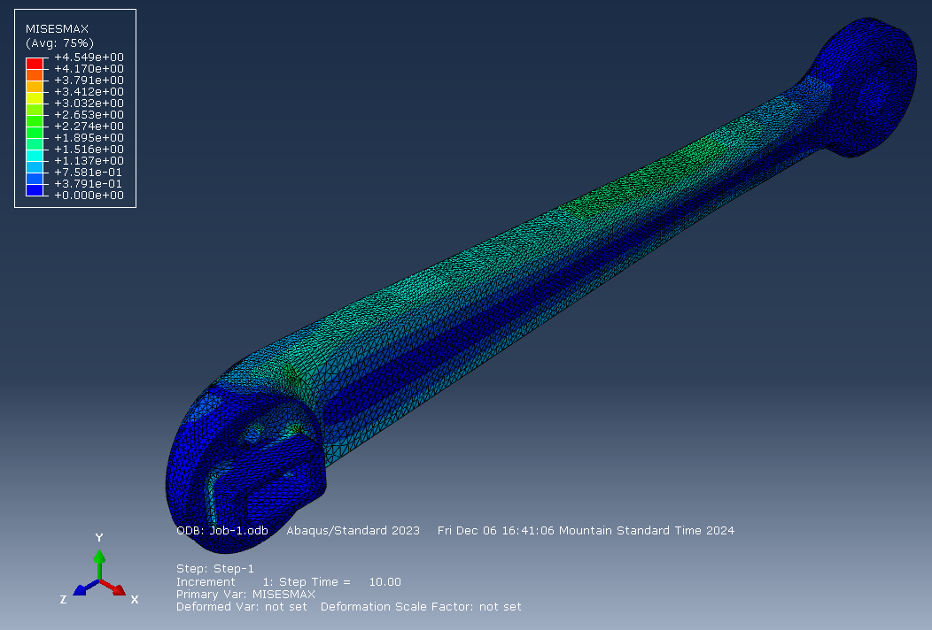

Figure 2: Stress concentration analysis of robot weight on leg segment

From the FEA analysis, as shown in Figure 2, we expect the stress to be concentrated around the bends with a maximum stress estimated by the model to be 4.55 MPa. From [1], we gather that the yield strength of our leg is 26.082 MPa. Our prototype will have a design factor of safety of 5.7, which is more than enough to withstand testing for motor stall torque. This theoretically means that there is some room before yielding, allowing room for possible 3-leg analysis in the future.

**Appendix C: Actuator Design**

Figure 3 shows the actuator design. The motors are geared through the belts to a ratio of 10:1 at the joint. The motors have incremental encoders with 5000 counts per rotation attached to their shafts. The left image shows the top portion of the actuator, which links the central gear to the bottom gear.

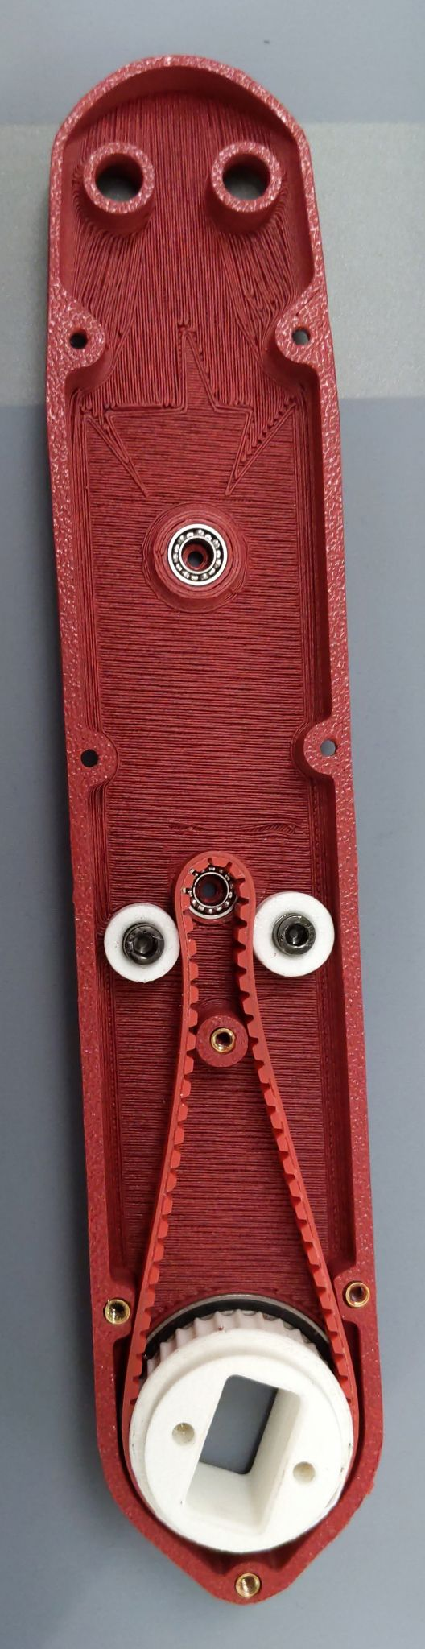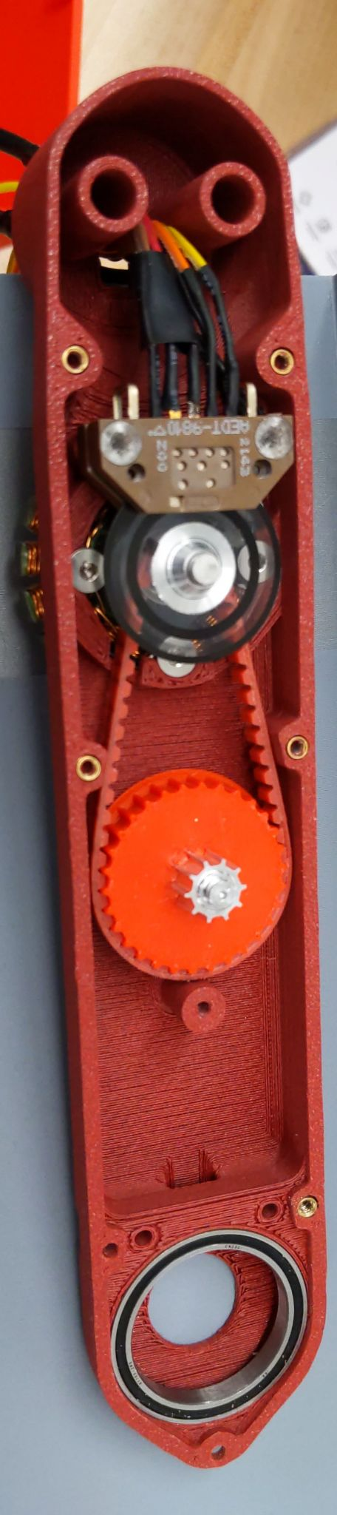

Figure 3. The open actuator used to drive each leg joint. The motor is located at the top, while the joint is at the bottom.